|  |  |  |  |
| --- | --- | --- | --- |
| **School of Electronics Engineering (SENSE)** | | | |
| **J COMPONENT – REPORT** | | | |
| **COURSE CODE / TITLE** | BECE403E – EMBEDDED SYSTEM DESIGN | | |
| **PROGRAM / YEAR/ SEM** | B.Tech III Year/ WINTER 2024-2025 | | |
| **LAST DATE FOR REPORT SUBMISSION** | 24.04.2025, 11.59PM | | |
| **DATE OF SUBMISSION** | 22.04.2025 | | |
| **TEAM MEMBERS**  **DETAILS** | **REGISTER NO.** | | **NAME** |
| 22BEC1205 | | Jayakrishnan Menon |
| 22BEC1219 | | Kalyaneswar Pulipati |
| 22BEC1075 | | Shivam Kumar Giri |
|  | |  |
|  | |  |
| **PROJECT TITLE** | **Simple and Cost Effective Heart Health Monitor** | | |
| **COURSE HANDLER’S NAME** | **Dr.S.Muthulakshmi** | **REMARKS** | |
| **COURSE HANDLER’S SIGN** |  |

***Certificate***

This is to certify that the Project work titled “Real-Time QRS Detection Algorithm” is being submitted by Shivam Kumar Giri – 22BEC1075, Jayakrishnan Menon-22BEC1205 and Kalyaneswar Pulipati 22BEC1219 for the course BECE403E, Embedded System Design is a record of bonafide work done under my guidance. The contents of this project work, in full or in parts, have neither been taken from any other source nor have been submitted to any other Institute or University.

Dr. Muthulakshmi S

Professor

**ACKNOWLEDGEMENT**

We wish to express our sincere thanks and deep sense of gratitude to our project guide, Dr. S. Muthulakshmi, School of Electronics Engineering, for his consistent encouragement and valuable guidance offered to us in a pleasant manner throughout the course of the project work. We are extremely grateful to Dr. A. Ravi Sankar, Dean of School of Electronics Engineering, VIT Chennai, for extending the facilities of the school towards our project and for his unstinting support. We express our thanks to our Head of the Department Dr. K. Mohanaprasad for his support throughout the course of this project. We also take this opportunity to thank all the faculty of the school for their support and their wisdom imparted to us throughout the course. We thank our parents, family, and friends for bearing with us throughout the course of our project and for the opportunity they provided us in undergoing this course in such a prestigious institution.





Jayakrishnan Menon Kalyaneswar Pulipati



Shivam Kumar Giri

**OBJECTIVE**

The primary objective of this project is to design and implement a compact, low-power, and cost-effective heart health monitoring system that leverages embedded hardware to facilitate real-time cardiovascular assessment. Specifically, this system employs the ESP32 NodeMCU-32S microcontroller in conjunction with the HW-827 Photoplethysmogram (PPG) sensor to acquire physiological signals related to cardiac activity. By integrating the well-established Pan-Tompkins algorithm within the embedded environment, the system aims to accurately detect QRS complexes and compute essential heart rate variability (HRV) metrics that are indicative of the autonomic nervous system’s regulation of the heart.

Key HRV parameters such as the standard deviation of NN intervals (SDNN), root mean square of successive differences (RMSSD), and the proportion of successive RR intervals differing by more than 50 milliseconds (pNN50) are calculated in real time. These parameters provide clinically relevant insights into cardiac function, stress response, and potential arrhythmic conditions.

The entire system is developed using the Arduino IDE, allowing for rapid prototyping and ease of deployment on the ESP32 platform. The processed metrics are displayed on a 16x2 I2C LCD module, offering immediate and continuous feedback to users. By combining digital signal processing techniques with accessible embedded hardware, the project aims to demonstrate the practical feasibility of deploying advanced biomedical algorithms in wearable or point-of-care monitoring systems, particularly in low-resource settings where conventional ECG monitoring may not be available.

**BLOCK DIAGRAMS**

**General Block Diagram:**

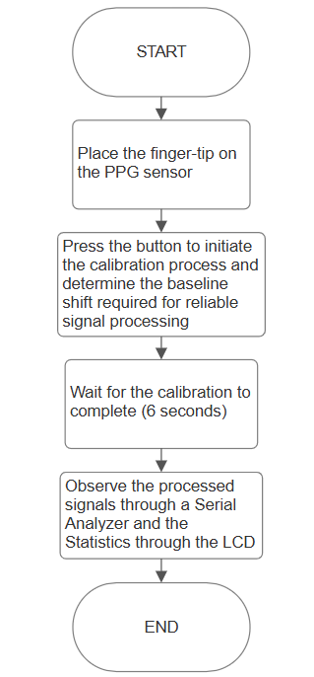

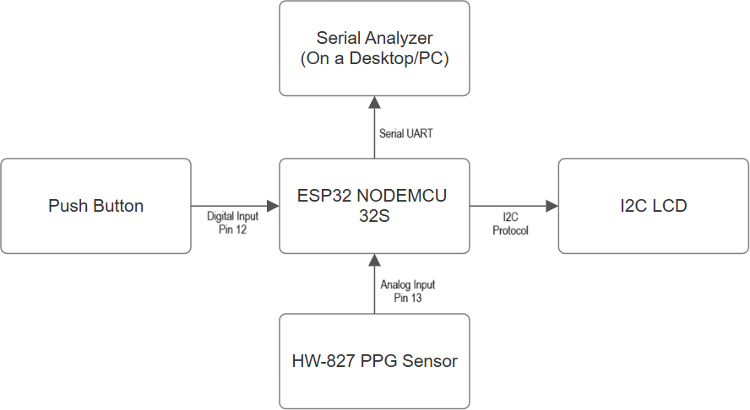**Hardware Block Diagram: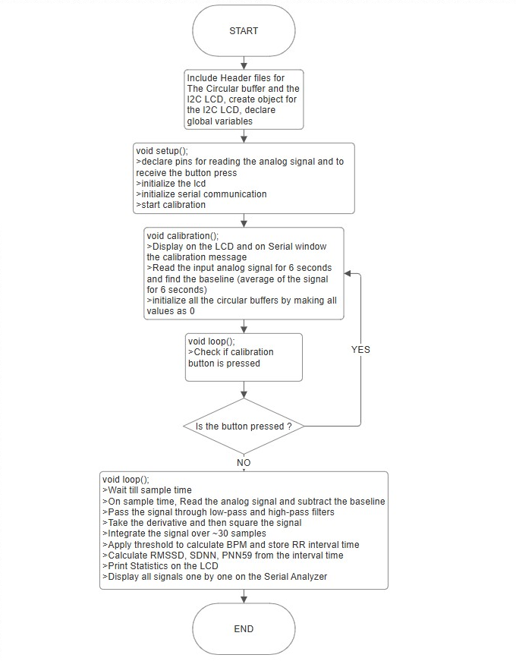Software Block Diagram:**

**Block Diagram explanation:**

The general block diagram provides a top-level view of the system's operational flow for heart health monitoring. The process begins when the user places their fingertip on the HW-827 PPG sensor, which detects blood volume changes and outputs an analog signal. The user is then instructed to press a button to initiate the calibration process, which adjusts for baseline offset and ensures reliable signal acquisition. The system waits for 6 seconds during calibration, after which the ESP32 NodeMCU-32S processes the input data. The processed signals are visualized through a serial analyzer on a desktop or PC, while key physiological statistics such as BPM, SDNN, RMSSD, and pNN50 are displayed on an I2C-based LCD. This flow captures the system’s high-level user interaction and real-time feedback mechanism.

The hardware block diagram details the physical interfacing and signal flow between key components. At the center is the ESP32 NodeMCU-32S microcontroller, which orchestrates the entire operation. It receives analog input from the HW-827 PPG sensor through pin 13 and digital input from the push button on pin 12. The I2C LCD display is connected via the I2C protocol for displaying heart rate variability statistics in real time. Additionally, the ESP32 transmits serial data through UART to a desktop-based Serial Analyzer for waveform visualization. This block highlights the simplicity and efficiency of the hardware connections, demonstrating how minimal components can support a robust biomedical monitoring solution.

The software block diagram illustrates the logical flow of the embedded code executed on the ESP32. It starts with the inclusion of necessary libraries (e.g., CircularBuffer and LiquidCrystal_I2C), declaration of variables, and pin configurations. During setup(), the LCD and serial monitor are initialized, and the calibration process begins. The calibration() function reads analog samples for 6 seconds, computes the average baseline, and resets the circular buffers. In the loop(), the system checks for calibration triggers and processes the incoming PPG data by applying the Pan-Tompkins filtering stages—low-pass, high-pass, derivative, squaring, and integration. QRS peaks are detected using a fixed threshold, and RR intervals are used to calculate HRV metrics. The system then updates the LCD display and serial output accordingly. This software logic ensures that physiological signals are processed in real time with minimal latency.

**COMPONENTS REQUIRED**

**Hardware:**

| **Component** | **Specification / Description** |
| --- | --- |
| ESP32 NodeMCU-32S | Dual-core microcontroller with Wi-Fi + Bluetooth, Arduino-compatible |
| HW-827 PPG Sensor | Optical pulse sensor for real-time heart rate signal acquisition |
| 16x2 I2C LCD | Display unit for showing BPM and HRV metrics |
| Push Button | Used to trigger calibration process |
| Jumper Wires | For making circuit connections between modules |
| USB Cable / Power Supply | Supplies 5V power to the ESP32 board |

**Software:**

| **Software / Library** | **Purpose / Description** |
| --- | --- |
| Arduino IDE | Programming and uploading code to the ESP32 |
| Serial Analyzer Software | Real-time visualization of signals as well as its spectral properties |
| LiquidCrystal_I2C.h | Controls I2C-based LCD display |
| CircularBuffer.hpp | Manages signal history using fixed-size circular buffers |
| Wire.h | Enables I2C communication between ESP32 and LCD |

**PROJECT DESCRIPTION**

The system titled Simple and Cost Effective Heart Health Monitor enables real-time monitoring of cardiovascular activity using embedded signal processing. It utilizes a photoplethysmographic (PPG) sensor to capture pulse waveforms from a user’s fingertip and processes the signal using the Pan-Tompkins QRS detection algorithm. The ESP32 NodeMCU-32S microcontroller handles all signal processing, HRV parameter computation, and data display. The system is designed for accessibility and portability, targeting low-resource environments to support early detection of cardiac anomalies.

**Process Workflow:**

**1. Signal Acquisition:**

* The HW-827 PPG sensor is used to detect the volumetric variations of blood circulation from the user’s fingertip.
* A push button allows users to initiate the calibration routine, which measures the average signal over 6 seconds to determine the baseline offset.
* The ESP32 collects analog signals from the sensor and digitizes them for processing.

**2. Signal Processing:**

* The ESP32 executes a digital signal pipeline involving:
  + Low-pass and high-pass filtering for noise reduction
  + Differentiation to highlight slope information
  + Squaring to amplify the signal
  + Moving Window Integration (MWI) to extract QRS wave features
* A threshold-based logic detects valid QRS peaks and calculates RR intervals.

**3. HRV Metrics Computation:**

* Once RR intervals are established, the system calculates:
  + SDNN – Standard Deviation of NN Intervals
  + RMSSD – Root Mean Square of Successive Differences
  + pNN50 – Percentage of successive RR intervals differing by more than 50 ms
* These metrics reflect cardiac health and autonomic nervous system performance.

**4. Data Display and Output:**

* The I2C 16x2 LCD module continuously displays BPM, SDNN, RMSSD, and pNN50.
* Processed signal data is also streamed via Serial UART to a desktop-based Serial Analyzer for waveform visualization.

**Signal Calibration System:**

**1. Baseline Detection:**

* During the initial 6-second calibration phase, the system averages incoming PPG signals to compute the baseline offset.
* This offset is subtracted from subsequent readings to ensure consistent and accurate signal processing.

**2. Noise Handling:**

* Signal artifacts and noise from finger movement or ambient light are minimized through multi-stage digital filtering embedded in the ESP32 code.
* Circular buffers help maintain smooth data flow and temporal alignment of filters.

**Data Flow and Presentation:**

**1. Data Flow:**

* PPG Sensor → ESP32 → LCD / Serial Analyzer
* Signal is acquired and processed onboard before being presented both visually and digitally.

**2. Presentation Layer:**

* LCD provides continuous feedback on HRV metrics to the user.
* Serial Analyzer displays waveform transformations such as raw signal, filtered signal, derivative, and integration stages.

**Definition and Description of Technologies Used:**

1. ESP32 NodeMCU-32S: A dual-core microcontroller that performs real-time QRS detection and HRV calculation while supporting serial and I2C communications.
2. HW-827 PPG Sensor: An optical pulse sensor that captures heartbeats based on blood volume changes in the fingertip.
3. I2C LCD (16x2): A character display module that shows BPM and HRV statistics in real-time using the I2C communication protocol.
4. Push Button: Triggers signal calibration for baseline adjustment prior to data collection.
5. Arduino IDE: Development platform for writing and uploading embedded code to the ESP32.
6. Serial Analyzer: A desktop-based visualization tool used to monitor signal processing stages and verify algorithmic behavior.

**IMPLEMENTATION**

The developed prototype of the Simple and Cost Effective Heart Health Monitor was successfully assembled and tested under various operating conditions. Photographs of the working model demonstrate the system capturing real-time PPG signals, performing baseline calibration, and displaying heart rate and HRV metrics on the I2C LCD screen. The setup includes the ESP32 NodeMCU-32S, HW-827 PPG sensor, push button for calibration, and serial monitoring on a PC. A working video demo showcasing the system's functionality, including live BPM and HRV computation, is available on YouTube at the following link: [**https://youtu.be/aAd_IqKLey0**](https://youtu.be/aAd_IqKLey0)

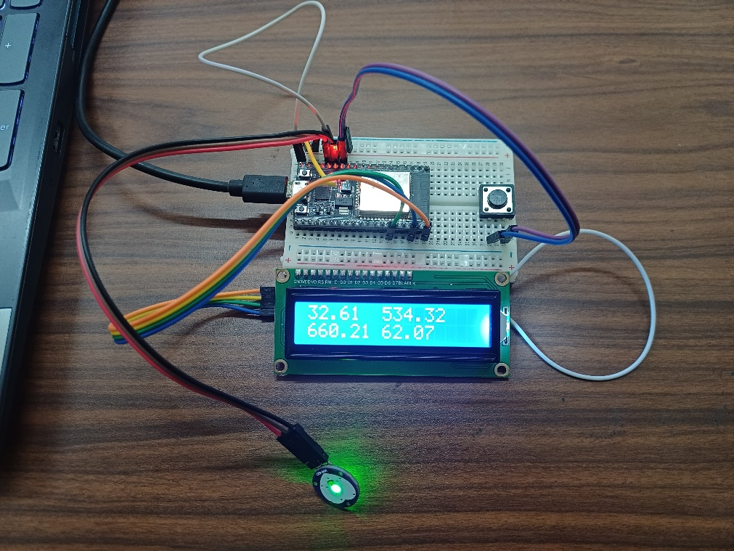

Prototype displaying real-time HRV metrics on LCD using ESP32 and HW-827 sensor.

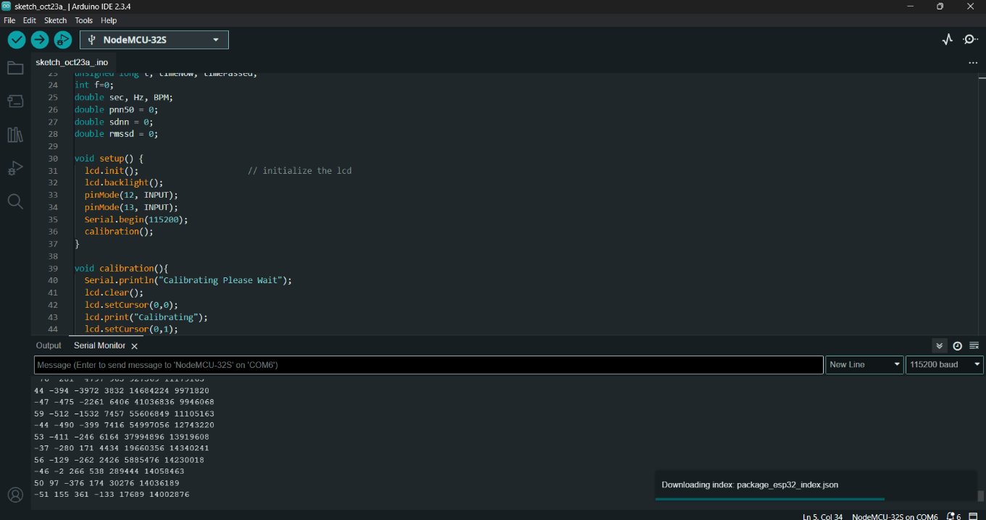

Arduino IDE showing real-time serial output of processed PPG signals and HRV data from the ESP32 NodeMCU-32S during system operation.

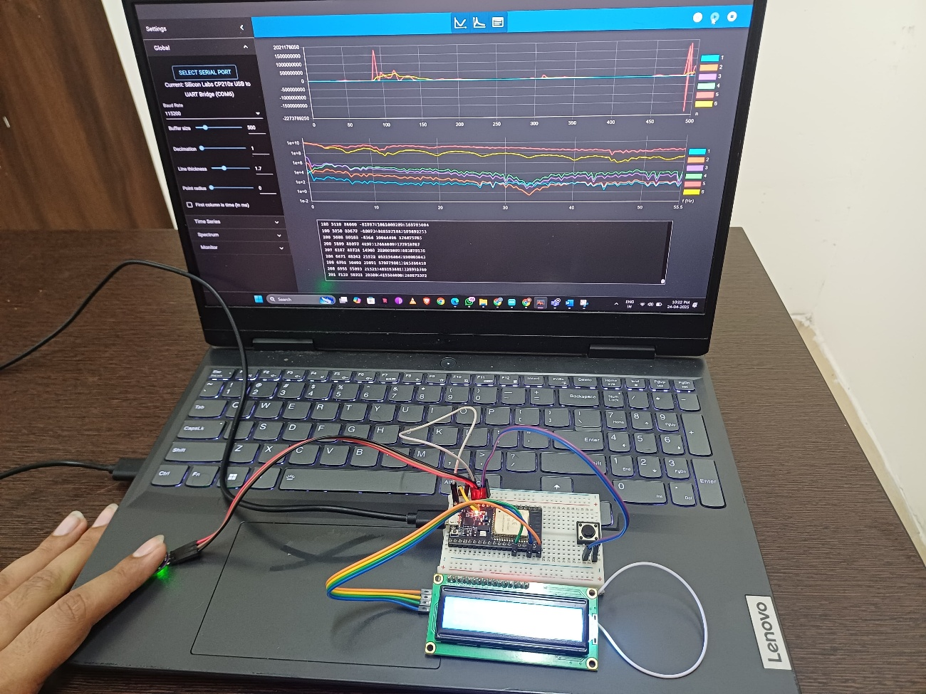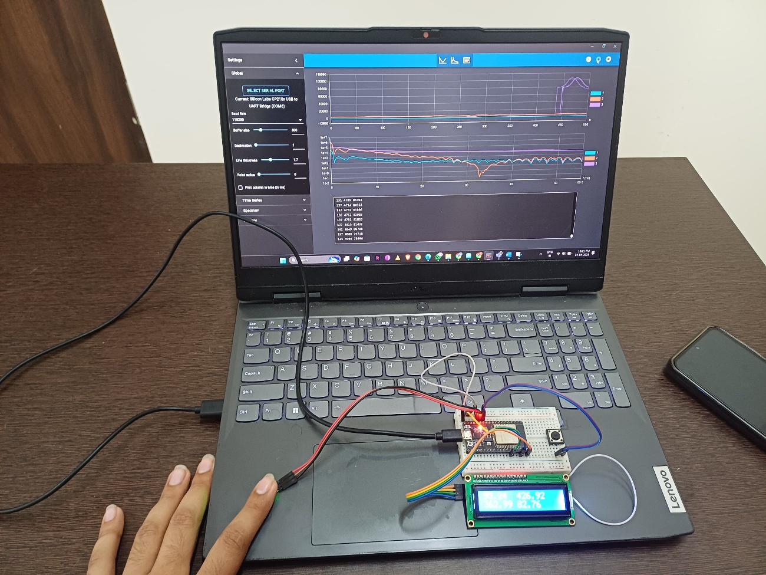

Visualization of squaring and moving window integration outputs in the Serial Analyzer, representing the final stages of Pan-Tompkins signal processing before QRS peak detection.

Live high-pass filter output of the PPG signal observed on the Serial Analyzer, with real-time HRV metrics displayed on the LCD during fingertip pulse acquisition. The BPM value displayed on the LCD is 95.24

**CHALLENGES FACES**

One of the primary challenges encountered during this project was adapting the Pan-Tompkins algorithm, originally designed for ECG signals, to work effectively with PPG signals. The Pan-Tompkins method relies heavily on the presence of sharp and well-defined QRS complexes found in ECG waveforms. However, PPG signals tend to exhibit smoother and less abrupt transitions, lacking the sharp slope characteristics that the algorithm expects. This led to an initial mismatch in performance until signal processing steps were fine-tuned to suit the PPG morphology.

Another significant obstacle was the issue of signal overflow due to large, uncorrected baseline values. In the initial implementation, the system processed raw analog readings directly from the sensor, which resulted in unexpectedly large numerical values propagating through the filtering and squaring stages. This led to frequent overflows and invalid outputs. Through iterative debugging, we discovered that subtracting a baseline offset prior to processing was essential. Consequently, we added a calibration routine triggered by a button press, allowing the system to measure and subtract the average baseline value for each new user.

The default filter coefficients in the Pan-Tompkins algorithm are tuned for ECG signals within the 5–12 Hz range, which aligns well with the typical frequency content of QRS complexes. However, PPG signals differ significantly in their spectral characteristics, with most of their meaningful components residing in the 0.5–5 Hz band. Initially, we considered modifying the filter design to better accommodate the PPG signal profile. Despite this mismatch, we found that the implemented filter configuration did not significantly attenuate the PPG components in the 5–12 Hz band, and most of the suppression occurred beyond 30 Hz, which is ideal for noise rejection. The frequency spectrum of the filtered signal confirmed that the effective cutoff appeared just above 30 Hz, preserving the desired PPG waveform features while eliminating higher-frequency noise. Consequently, we chose to retain the original filter structure from the ECG-based Pan-Tompkins approach, as it offered effective noise reduction without compromising signal quality.

We also encountered a technical challenge related to numerical overflow during the squaring stage of the algorithm. At first, this was misinterpreted as an error in filter design or data scaling. Upon further investigation, we identified the root cause as datatype limitations. Transitioning from standard integer types to long long resolved the overflow issue and allowed the squaring operation to execute correctly without corrupting downstream data.

The thresholding technique described in the original Pan-Tompkins paper proved to be complex and highly tailored to ECG signals. Due to its dependence on adaptive floating thresholds and dual-signal evaluation, we faced difficulty implementing it accurately in our constrained embedded environment. As a workaround, we introduced a manually defined threshold value to detect peaks. Although this approach was sufficient in most cases, it occasionally led to anomalously high BPM readings—spiking above 200—likely due to misidentified noise or early peaks. Nonetheless, the output remained within acceptable bounds under steady signal conditions.

Lastly, the hardware limitations of the HW-827 PPG sensor posed challenges in data consistency. The sensor was highly susceptible to motion artifacts, especially those caused by minor muscle movements or unstable finger placement. While this sometimes introduced transient noise into the signal, we were able to mitigate its impact by maintaining steady hand positioning and relying on the filter stages to clean the input.

**APPLICATIONS**

The developed heart health monitoring system demonstrates significant potential in cost-effective personal healthcare, especially in low-resource and remote settings. Its use of affordable components—such as the ESP32 NodeMCU-32S microcontroller, HW-827 PPG sensor, and I2C LCD—makes it highly accessible to individuals without access to expensive diagnostic tools. The real-time calculation of heart rate variability (HRV) metrics including SDNN, RMSSD, and pNN50 enables early detection of cardiovascular stress and autonomic dysfunction, providing timely insights into a user's health condition.

This system is particularly well-suited for home-based cardiac health monitoring, especially for elderly individuals or patients with known heart conditions who require daily HRV tracking without needing to visit a clinic. Its portability and ease of use make it ideal for wearable or bedside integration, empowering users to track and respond to cardiac irregularities promptly.

Beyond personal health monitoring, the project can be extended to telemedicine platforms, where vital statistics can be transmitted to healthcare providers in real-time using Wi-Fi or Bluetooth modules integrated with the ESP32. This can be especially beneficial in rural areas where medical professionals are not readily available.

Additionally, the core signal processing framework can be adapted for athlete performance monitoring. HRV is a widely recognized marker for recovery, fatigue, and training load. Athletes can use a tailored version of this device to evaluate training intensity and recovery cycles, optimizing performance while minimizing risk of overtraining.

The system may also find applications in mental health assessment, as HRV metrics are often used to gauge stress, anxiety, and emotional regulation. Integrating the device with smartphone applications could enable continuous mental wellness tracking in a non-invasive and user-friendly manner.

Furthermore, the algorithmic structure can be extended to clinical research settings, where it can serve as a prototyping platform for testing and validating new HRV analysis techniques on embedded systems. The open and modular nature of the implementation makes it suitable for educational purposes, allowing students and researchers to understand biomedical signal processing and embedded system integration firsthand.

**CONCLUSION**

The project titled “Simple and Cost Effective Heart Health Monitor” successfully achieves its objective of developing a low-cost, real-time heart monitoring system using the ESP32 NodeMCU-32S microcontroller and the HW-827 PPG sensor. The system implements a modified version of the Pan-Tompkins algorithm, which—despite being originally tailored for ECG signals—was effectively adapted to work with the comparatively smoother PPG waveforms. Through the stages of digital filtering, differentiation, squaring, and moving window integration, the system was able to detect pulse peaks and compute vital Heart Rate Variability (HRV) metrics such as SDNN (Standard Deviation of NN intervals), RMSSD (Root Mean Square of Successive Differences), and pNN50 (Percentage of successive RR intervals differing by more than 50 ms).

Throughout the development process, several challenges were encountered and overcome. These included signal overflows caused by baseline shifts, which were resolved through the implementation of a calibration routine triggered by a push button to determine and subtract the user-specific baseline before signal processing. Furthermore, datatype limitations that affected the squaring function were addressed by transitioning to a 64-bit long long format. Although the default filter configuration in Pan-Tompkins was not ideally suited to PPG’s frequency range, its noise suppression capabilities and minimal impact on signal integrity made it viable without modification. Additionally, a simplified manual thresholding technique was used in place of the complex dual-threshold system, providing stable results in most cases, with occasional spikes managed through observation and tuning.

The real-time nature of the system—visualized both on a 16x2 I2C LCD and via the serial monitor—makes it especially well-suited for portable and continuous health monitoring. Users can receive immediate feedback on their cardiovascular metrics, enabling them to monitor stress, fatigue, or irregularities without the need for clinical-grade equipment. The system’s affordability and ease of assembly further make it suitable for deployment in rural clinics, home-based care for elderly patients, and wellness applications for fitness enthusiasts.

Moreover, the modular and open-source nature of the system allows for future scalability. It can be integrated with wireless communication modules (Wi-Fi/Bluetooth), cloud storage platforms, or mobile applications to support telemedicine, remote diagnosis, and data logging. With enhancements, it could also be incorporated into wearable devices or smart health platforms, making it a versatile building block in the broader domain of biomedical engineering and digital health.

In conclusion, this project not only meets its technical goals but also provides a strong foundation for continued development in the area of affordable, embedded cardiac health monitoring systems. It bridges the gap between theoretical biomedical algorithms and practical real-world implementations, demonstrating how embedded technology can make meaningful contributions to preventive and accessible healthcare.

**BIO DATA**

Name: Jayakrishnan Menon

Registration No: 22BEC1205

Email: [jayakrishnan.menon2022@vitstudent.ac.in](mailto:jayakrishnan.menon2022@vitstudent.ac.in)

Mobile number: 7200323590

Name: Kalyaneswar Pulipati

Registration No: 22BEC1219

Email: [pulipati.k2022@vitstudent.ac.in](mailto:pulipati.k2022@vitstudent.ac.in)

Mobile number: 6281484142

Name: Shivam Kumar Giri

Registration No: 22BEC1075

Email: shivamkumar.giri2022@vitstudent.ac.in

Mobile number: 9334372094